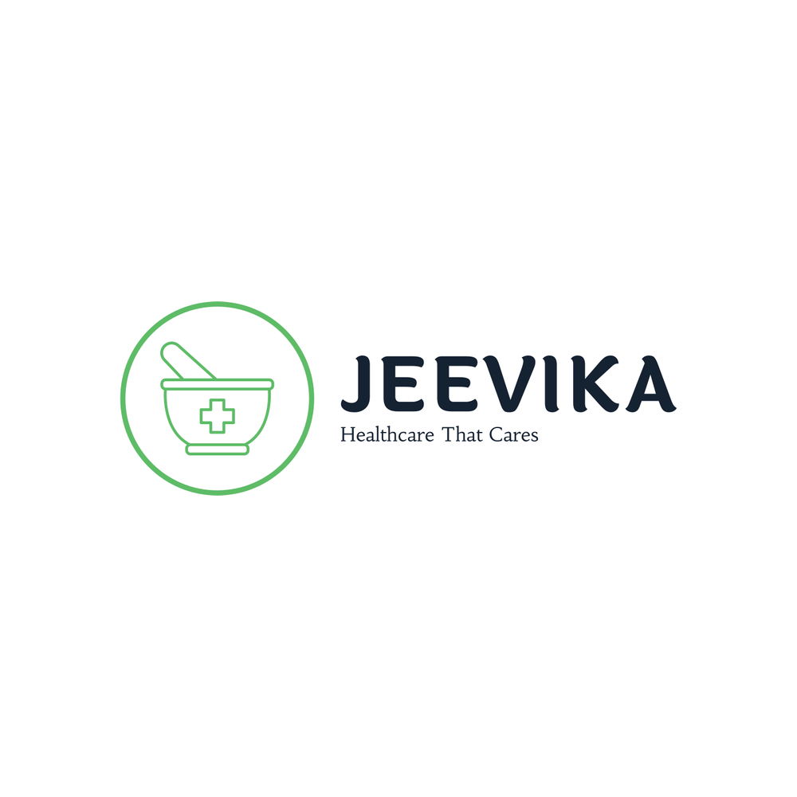Team 09

Business Report

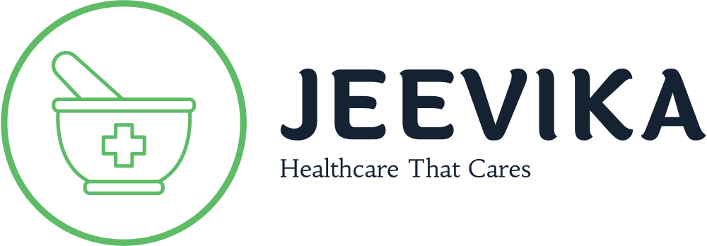

**Team Members**

ADITYA - 21BCE11104 (Team Leader)

SHASHWAT TIWARI - 21BCE11378 (Marketing)

SHASHWAT PANDEY - 21BCE11596 (Management)

AISHWARYA MISHRA - 21BCE10121 (Finances)

PALAK BAIS - 21BCE11546 (Medical Research)

**Table of Contents**

* Title Page
* Executive Summary
* Business Idea and Goals
* Marketing
* Operations
* Finances
* Business Background
* Mission Statement
* Business Goals
* Understanding the Market
* Market Research and Analysis
* Marketing Plan
* Operations and Production
* Legal Requirements
* Management Details
* Organizational Structure and Staffing
* Insurance & Security
* Finance
* Income and Expenses
* Timeline
* Set-up period
* Finance Timeline

**Executive Summary**

***Business Ideas and Goals***

Our country is the second largest in the world in terms of population. The ratio of doctors to population in India is 1:1000 (courtesy to WHO), which is a significant number in itself. However, during the COVID-19 pandemic, the availability of medicines and healthcare was scarce. People were not able to procure medicines for their ailments during this period. Also, people were not able to avail the services of speciality doctors, like dermatologists and cardiologists, due to the lockdown. Now that the lockdown is over, we still face many problems, regarding procuring specialized drugs and implant components, availing the services of speciality doctors due to unavailability of appointments.

To address these problems, we initiated JEEVIKA. JEEVIKA is able to solve these problems and also provide various small, but really helpful facilities. JEEVIKA can make appointments to the appropriate doctors for you, can order medicines for you, can store your medical records, lab reports, allergy reports, blood test reports and many more. JEEVIKA can keep track of your physical statistics too. JEEVIKA is a website, that can be accessed by the customer in any device with internet access.

We intend to create a system that will be the core of communication within healthcare industry. A system which will store the records of a patient’s past medical history, the current diagnosis, and ongoing medical procedure. A system that will prioritize the patients’ well-being before anything else. A system that will, in time, become self-sustained.

***Marketing***

JEEVIKA has two major selling points; the first getting the medicine to patients, and the second, is getting the patients the right doctors.

JEEVIKA will provide the best prices for our customers on their prescribed medications. Our target market consists of two groups; local customers or walk-ins, and mail order customers.

JEEVIKA will help people reach the right doctors that specialize in treating the patient’s ailments. Our target market will consist of lower-class and middle-class customers, i.e., the group of people that are not as aware regarding healthcare as the upper-class group.

***Operations***

JEEVIKA will be working using an online platform as well as walk-in stores. This kind of operation system gives us an edge over our competitors, who either provide only mail-order services or walk-in services.

We will connect with the doctors over an extensive network that will allow them to communicate with each other as well as the patients. Through this network they can access their patient’s medical records, enabling them to perform accurate diagnoses and form a treatment procedure that will be most beneficial to the patient.

***Finances***

Since JEEVIKA is using both online and offline platforms, that reduces the strain on the need of employees. Still, we will need people for delivery services, pharmacists for walk-in stores, experts for handling the online server, and people for the communications department. We intend to have substantial sales by the fourth fiscal year. Due to the fact that JEEVIKA will provide medicines for a lower value than market value, the financial gains will be slow but gradual.

**Business Background**

***Mission Statement***

Our mission is to get the patients the right doctors, and the right medicines at low costs and within the least possible time.

JEEVIKA is about making the unaware public cognizant of the facilities that could help them prevail against their ailments, to allow them to make use of the facilities and treatment procedures that are available in the medical institutes but not so popular.

***Business Goals***

*Short Term Goals*

* To procure funding from various government schemes as base capital.
* To establish a network with pharmaceutical companies to get products directly from their production units.
* To establish a network with doctors and hospitals so that we can get them properly connected with the customers.
* To create awareness among people about how JEEVIKA would be beneficial to them.
* To advertise about JEEVIKA through various online as well as offline platforms.
* To establish a firm delivery system for mail order customers.

*Long Term Goals*

* To create a system of interaction between the patients and the doctors that will enable accuracy in diagnosis and treatment procedure.
* To create stable trade with pharmaceutical production companies.
* To establish a chain of pharmacies that provide customers with medication at a comparatively low cost than other private pharmacies.
* To create an organization that will work in compliment to the government medical institutes across the country.

**Understanding the Market**

***Market Research and Analysis***

Right now, JEEVIKA’s target market is the Indian pharmaceutical supply market. India’s pharmaceutical market took a hit right at the beginning of the COVID-19 pandemic, since there was either precautionary medication nor any treatable medication against Corona Virus. But right now, the pharmaceutical market is booming.

Also, JEEVIKA will target the online consultation market that is on a growth spree within India. What JEEVIKA will provide is simple, get the customers the information about the doctors they can consult to regarding their ailments, get them appointment to the selected doctor in a time period of their choosing,

***Industry***

*According to the Indian Economic Survey 2021, India’s domestic pharmaceutical market stood at US$ 42 billion in 2021 and is likely to reach US$ 65 billion by 2024 and further expand to reach US$ 120-130 billion by 2030*. Which means that *this is a growing market that has potential to grow even more in the foreseeable future with the advances we are seeing in biotechnology industry*, such as biopharmaceuticals, bio-services, bio-agriculture, bio-industry, and bioinformatics. Henceforth, it can be said that this comparatively small market today can be a game-changer within the next 20 years. Therefore, any kind of decrease in product cost cannot be seen for at least the next 10 years. Medicine spending in India is projected to grow 9-12% over the next five years (courtesy to IBEF), leading India to become one of the top 10 countries in terms of medicine spending.

The next part is online consulting and appointment services. There are various medical institutes across the country that have their own online handle for virtual consulting, which have high fees and only make use of a small number of doctors.

Revenue in the Online Doctor Consultations segment is projected to reach US$93.33m in 2022 (courtesy to statista.com)..

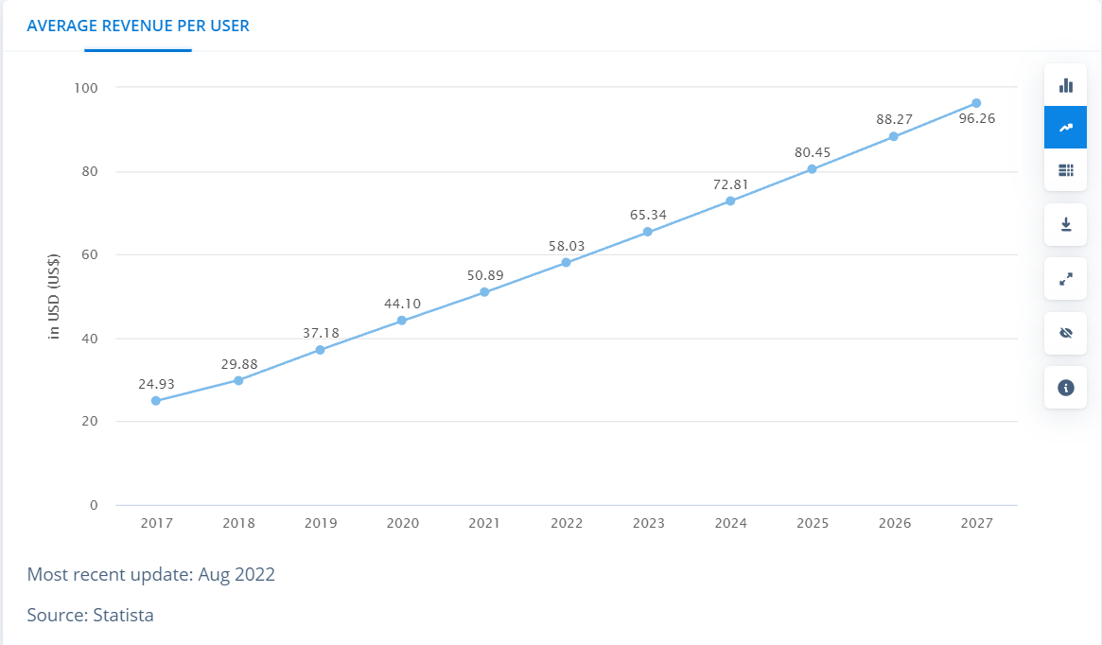

The customer penetration rate of the online consultancy market is 0.11% of current Indian population.

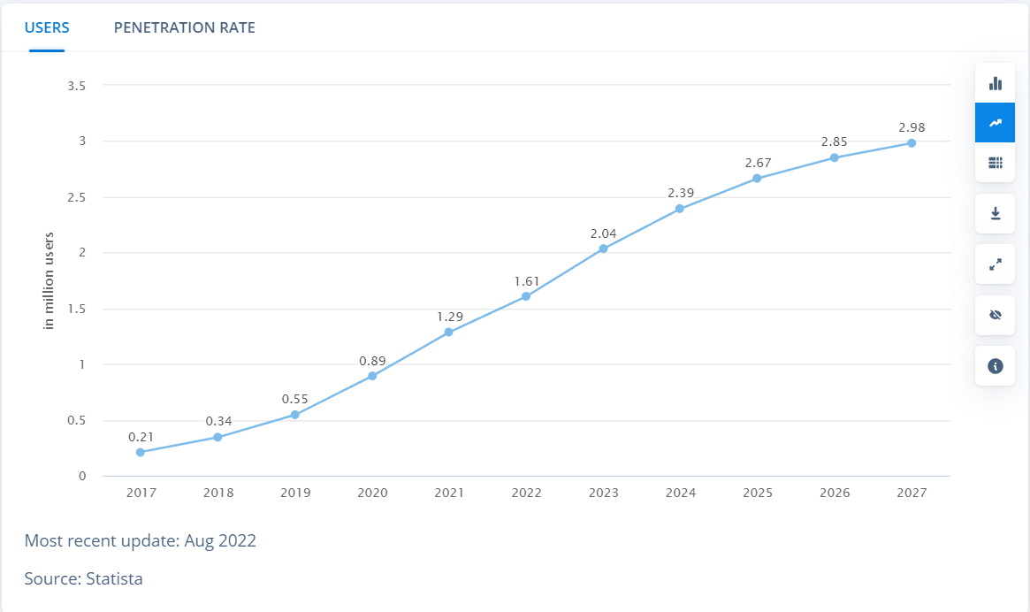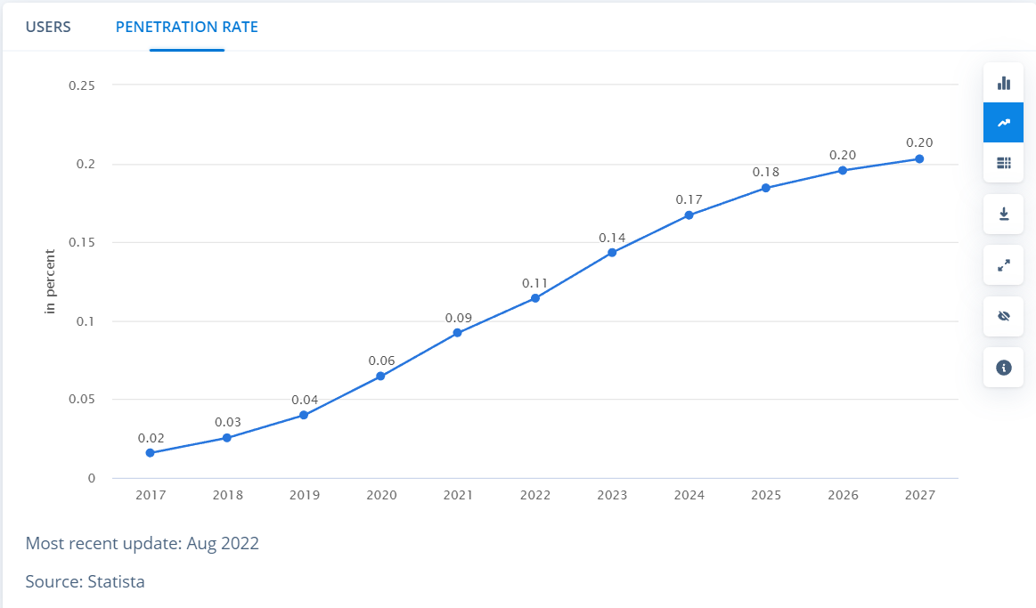

The number of users for this market is 1.61 million people.

The online medical consultancy market evolved during the COVID-19 pandemic, when people understood how important this service. As suggested from the graphs, the growth of this sector is slow but consistent, and after a certain amount of time in foreseeable future, the rate of growth will be exponential.

***Target Market***

Medicines are a daily necessity nowadays. From the youngest infant to the oldest elder, we all need medicines. So, it is clearly seen that our target market includes all the age groups. JEEVIKA targets the lower and the lower middle economic classes which cannot afford medication due to the severity of the cost. Any type of literate population can understand the difference of cost and utility of services provided by JEEVIKA are better than any other.

The type of customers can vary among three groups; end consumers, retailers and government or non-profit organizations. Now since JEEVIKA is moving the medication directly from the production units to the consumers, each of these types of customers are profitable for JEEVIKA.

End consumers will purchase the medication in small quantities, which will be actually the largest amount of our customer body. Retailers will purchase the goods in bulk quantities, which will be the second largest amount in the customer body. The smallest part of customer body will be non-profit organizations or government organizations. They will purchase the goods in similar way as the retailers, however only minimum margin of profit can be achieved.

Online consultation business will target both the doctors and the patients. JEEVIKA provides people with an opportunity to consult with the right doctors, both in person and via video conference. The doctors will be an entity free from JEEVIKA, just connected so as to facilitate better communication between them and the patients. JEEVIKA will also facilitate a network among the doctors, that will have a common database and a communication platform so that the doctors can confer among themselves regarding selecting the optimum diagnostics and treatment method for patients suffering with ambiguous ailments.

The patients can avail the online consultation services through making an appointment with the right kind of physician to treat their ailment. Also, JEEVIKA can make lab test appointments with labs that are budget friendly for our customers, can store their healthcare information for them, such as prescriptions.

***Competition***

There are two aspects of JEEVIKA, both being ambitious projects. Each of these aspects are part of a market that is a well-established business in developed economies, however in India, neither of these businesses were known to majority of Indian population till the onset of the COVID-19 pandemic. This gives JEEVIKA a certain degree of freedom towards experimentation over several aspects of this market.

The major competition for the medication providing business is;

* *Walmart Pharmacy*, this company has been trying to introducer the concept of wholesale and retail pharmacies in India right after the end of COVID-19 pandemic (Courtesy to Economic Times of India).
* *Rita Aid Corp*., this organization is a well-established chain of pharmacies in the USA and is planning to introduce wholesale pharmacies in India similar to Walmart Pharmacy (Courtesy to Economic Times of India).
* *Apollo Pharmacy* is the largest retail pharmacy chain in India with more than 4000 outlets in over 21 states. (Courtesy to Medical council of India)
* *1MG* is a generic drug research business*.* This digital health start-up maintains an online medicine database with information on side effects; generic substitutes, and provides home delivery services for pharmacy, FMCG and lab tests.
* *Pharmeasy* is an online website that delivers the medication to the customers from pharmacies that are associated with them. They also provide online diagnostics and telehealth services.
* *Netmeds* is an online pharmacy service that provides lab tests and online diagnostics along with courier service for medicines from pharmacy to customer.

The major competition for online medical consultancy business is;

* *Apollo 24/7* is the digital healthcare platform of the group which was launched in 2020. It offers telehealth consultation, online medicine ordering and delivery, and in-home diagnostics among other services. However, Apollo24/7 only employs the doctors that are associated with Apollo Hospitals.
* *Tata Health* is a telemedicine app that offers services like online consultation, appointment booking, lab tests and delivery of medicines. It also has a service called *Health Locker,* which allows user to store medical records online.
* *Mfine* is a healthcare platform that offers professional diagnostics and telemedicine services. It has services like at-home lab tests, X-Ray and scans booking, online consultation, delivery of medicines. The app also offers self-evaluation services for chronic medical conditions like diabetes, PCOD, cardiac health and many more.
* Lybrate is another popular telemedicine app. It has services like online consultation, appointment booking, lab test booking.

***SWOT Analysis***

*Strength­s*

* Medicines from well-known pharmaceutical companies will be supplied to the consumers at reduced rate as there will be no retailers and additional transportation charges.
* Use of ‘Every Day Low Prices’ strategy. JEEVIKA is based on economics of scale agenda, which is why we can supply the medications at a reduced price. Also, all the products will have a fixed price.
* Logistics system that will monitor the performances of the products in each JEEVIKA walk-in pharmacy, hence changing the price to maintain the margin of profit.
* JEEVIKA allows the users purchase the medicine just on the touch of the fingertip, the complete process is very convenient and user friendly.
* JEEVIKA will establish its pharmacies in suburban areas, where supply of medicines is not very sustained.
* JEEVIKA provides a generalized platform for patients at all circumstances to access the medicine purchase may it be elderly person, specially challenged or residing in a remote location, practically in all scenarios the user can access the information about drugs and medicines with associated services.
* JEEVIKA will cater for manufacturing and supply in bulk by selling on the online; thus, reducing the cost of medicines. Physical pharmacies require much inefficiency, such as small-scale storage of medicines; unlike JEEVIKA that produce in bulk and store in warehouses.
* 24/7 customer service available.
* JEEVIKA can also make appointments for the customers, store their medical data, including diagnostic reports, prescriptions, lab reports, allergies, etc.
* JEEVIKA will suggest the doctors to the customers based on their conditions.
* The sorting of doctors will be done on the basis of their ODEP rating, provided by the Medical Board of India, and a rating that will be provided by the customers.
* JEEVIKA will provide a common database to both, doctors and patients, so that the doctors can access the files of their patients at any place and time, given he has the consent from the patient. The doctor can also share the patient’s data with other doctors that he may wish to confer with via JEEVIKA.
* JEEVIKA will only serve a connecting medium between doctors and patients, hence removing any chances of unethical behaviour from the organization.
* Pharmacists will ensure that the medicines that are being sold to the patients are the ones that were prescribed by the doctor, by double checking the prescription number from the database.
* JEEVIKA will have an established system to deal with complaints and grievances of the customers via feedback and reviews.

*Weaknesses*

* Since the business itself is based on economics of scale agenda, rapid growth won’t be easy.
* Possibility of unsafe delivery of medicines.
* The stereotype within the general public regarding fake and low-quality medicines.
* Unethical behaviour from the doctors can cost hugely to JEEVIKA’s reputation.
* The time period required for having a stable margin of profit will be very long, and hence reaching the break-even point can take more than a few years.
* Any kind of disorder in logistics system may lead to complete failure of the sales strategy.

*Opportunities*

* *Increase in Market Value*. The rise in the pharmaceutical and healthcare market value within India is rapid and exponential, having increased by 300% within last 3 years (courtesy to Annual Budget Report).
* *Medical Requirements at a single platform*. Consumers are examining online pharmacy as a single place accessing all their medical requirements from medicine purchases to lab tests and medical consulting.
* *Demand for Healthcare Services.* Increase in lifestyle diseases like diabetes and cardiovascular disorders, especially among senior citizens. The expected increase in demand for healthcare services, particularly pharmaceuticals, is due to the growth within the senior population demographic.
* *Internet.* The number of people who use the internet is growing all over the world. This means that JEEVIKA has the opportunity to expand its online presence by interacting with its customers more through the internet.

*Threats*

* The increasing competition between retail and online, but as JEEVIKA is giving the customers the luxury of low prices, so we have an edge over them.
* Shift in customers’ behaviour.
* Rise in price by the suppliers will cause JEEVIKA to also increase the prices of the products.
* New or increased competition.

***Marketing Plan***

*Distributive channels*

JEEVIKA will have both, walk-in and mail order services. The website that will serve as an online interface for the customers will simplify the procedures that will take place.

Other distribution channels such as doctors, hospitals or pharmacies are viewed as weaker channels. Overall, the health market is still in the hype phase and integration must take place before telehealth facilities reaches its full potential.

*Pricing*

The pricing of our services and products will be budget friendly for lower and lower middle-class population of our society. The profit margin will be similar to that of a retail seller, but overall price will be less than the market price. To understand this concept, we need to understand that medical products go through multiple traders, like wholesale traders and retail traders. But we will be providing the medicines directly from manufactures to the customers, therefore reducing the additional expenses like transportation, taxes, price change, etc. Therefore, the margin will similar to that of a retail trader, but the cost will be significantly lesser than any other pharmacy.

***Operations and Production***

*Legal and Licensing Requirements*

* The Drugs and Cosmetics Act, 1940
* The Drugs and Cosmetics Rules, 1945, these both laws  have guidelines on the sale of Schedule H and Schedule X drugs.
* Narcotics Drugs and Psychotropic Substances Act, 1985

Below are the legal requirements to be fulfilled:-

* No person will distribute or sell, stock, exhibit or offer for sale of drugs through e-pharmacy portal unless registered.
* Any person who intends to conduct the business of e-pharmacy shall apply for the grant of registration to the Central Licensing Authority in Form 18 (AA) through the online portal of the Central Government.
* The application of registration of e-pharmacy will have to be accompanied by a sum of INR Rs. 50,000 while asserting that an e-pharmacy registration holder will have to comply with provisions of Information Technology Act, 2000 (21 of 2000).
* The details of the patient shall be kept confidential and not be disclosed to any person other than the central government or the state government concerned, as the case may be.
* The supply of any drug shall be made against a cash or credit memo generated through the e-pharmacy portal and such memos shall be maintained by the e-pharmacy registration holder as a record.
* New e-pharmacies have to be registered with the Central Drugs Standard Control Organization (CDSCO), India's apex drug regulator and central licensing authority.
* E-pharmacies have to take only one license in any state and can sell drugs all over the country even if they have one license.
* The sale of tranquilizers, psychotropic drugs, narcotics and habit-forming drugs have been prohibited through e-pharmacies portals.
* The premises of e-pharmacy shall be inspected, every 2 years by a team of officers authorized by the Central Licensing Authority, with or without the experts in the relevant field or the officers authorised by the concerned State Licensing Authority.
* The registration issued to any person for e-pharmacy will remain valid for a period of 3 years from the date of its issuance and a renewal of registration will have to be done in case it wants to continue.
* No e-pharmacy shall advertise any drug on radio or television or internet or print or any other media for any purpose.
* The e-pharmacies portals are mandatory required to have at least 12 Hours and all seven days a week customer support and grievance readdress of all stakeholders. The customer support should have a registered pharmacist in place to answer the queries of customers through such customer helpline.

Following are the licenses required to established the business:-

* Retail Drug License (RDL)
* Wholesale Drug License (WDL)

Following are the forms required for registration:-

* Application forms,
* Challan of fee deposited,
* Declaration form,
* Site plan (Blue print),
* Key plan (Blue print),
* Basis of possession of the premises,
* Proof of ownership of the premises, if rented,
* Proof of constitution of the firm (Certified copy),
* Affidavit of non-conviction of Proprietor/Partners/Directors under Drugs & Cosmetics Act-1940,
* Certified copy of Regn. Certificate of Delhi Pharmacy Council/Experience Certificate of the Registered Pharmacist/Competent person and qualification certificates,
* Bio-data form,
* Affidavit of Registered Pharmacist/Competent person regarding full-time working with the firm duly attested by Notary.

*Management Details*

* Web-based ordering systems, these systems allow pharmacists of JEEVIKA to order medications from the manufacturers.
* Perpetual inventory systems, the use of perpetual systems involves recording the quantity of medications continuously as the prescription is filled and dispensed. This way, the medication is automatically removed from inventory and you always have updated stock information.
* Automatic dispensing systems. These are machines that automatically count and dispense pills for a pharmacist. Some complex systems even print the label apply it to the bottle.
* Stock organization and counting. Medication counts are done regularly, but even that can’t help in the situation where drug amounts are counted incorrectly or not updated in the system on time. A PMS can keep a detailed log of your inventory that can be easily filtered by the required storage conditions and expiration date, allowing you to prevent dangerous errors.
* Medication ordering. A PMS uses reorder points or par levels set up by the pharmacy to generate automatic orders. The system calculates how many items are needed to raise the stock level and adds this quantity to the order. The orders are then sent via an electronic data interchange (EDI) method.

*Insurance and Security*

Every pharmacy faces unique liabilities, as well as the risks that can come up during normal operations, such as:

* Customer slip and falls
* Data breaches
* Car accidents
* Employee injuries or illnesses

That’s why business insurance for pharmaceutical companies is important. You can think of this coverage as a type of risk insurance that helps protect your pharmacy business in both the short-term and long-term.

Getting the right type of insurance coverage is an important part of every business’ risk management plan. In fact, most businesses start with a Business Owner’s Policy (BOP). It combines three essential coverages to help protect your pharmacy or drug store from claims arising from normal operations:

* General liability insurance helps cover claims that your business caused bodily injury or property damage to someone else’s belongings.
* Commercial property insurance, which helps protect your owned or rented building and equipment you use to run your pharmacy. This includes:
* Scales
* Shelves
* Pills and drugs
* Computer systems

Business income insurance to help replace your pharmacy’s lost income if you can’t open because of covered property damage.

The Health Insurance Portability and Accountability Act (HIPAA) of 1996 contains specific security rules to assure confidentiality and information protection.

***Finance***

*Income & Expenses*

*Government schemes –*

*Pradhan Mantri Mudra Yojana (PMMY)*

The Pradhan Mantri Mudra Yojana is a start-up funding scheme aimed at easing access to credit for micro and small enterprises in India. The PMMY is an initiative of the Government to support and finance entrepreneurial ventures which have the potential to create employment and increase incomes for more Indians.

*Credit Guarantee Trust Fund for Micro and Small Enterprises (CGT-MSE)*

This scheme was set up to provide business loans to micro-level businesses, small-scale businesses, and start-ups with no security. Under this scheme, the eligible MSEs can obtain a maximum amount of up to Rs. 1 crore through the Ministry of MSME and Small Industries Development Bank of India (SIDBI).

*Multiplier Grants Scheme (MGS)*

Under this scheme, if the industry supports the research and development of products that can be commercialized at the institutional level, the government shall provide financial support which will be up to twice the amount provided by the industry.

*Ayushman Bharat Pradhan Mantri Jan Arogya Yojana (AB-PMJAY)*

This is a part of the Indian Government's National Health Policy. This government scheme aims to empower the poor and economically vulnerable population of the country to receive quality healthcare.

**Financial Projection**

Cost-Sheet

|  |  |  |  |
| --- | --- | --- | --- |
| One-time expense | Amount | Regular Expenses | Amount |
| Office Set-up | ₹5,00,000 | Office Rent | ₹50,000 |
| Hardware, Accessories | ₹45,00,000 | Technical Services | ₹75,000 |
| Utilities | ₹10,00,000 | Legal Services | ₹50,000 |
| Infrastructure | ₹1,00,00,000 | Salary | ₹10,00,000 |
| Incorporation and Trademark | ₹7,000 | Advertisement | ₹5,00,000 |
| **Total** | **₹1,60,07,000** | Miscellaneous | ₹3,00,000 |
|  |  | **Total** | **₹19,75,000** |

Investments

|  |  |
| --- | --- |
| Government Schemes | ₹1,00,00,000 |
| Loan | ₹50,00,000 |
| Investors | ₹1,00,00,000 |
| Private fundings | ₹50,00,000 |
| **Total** | **₹3,00,00,000** |

***Timeline***

|  |  |
| --- | --- |
| **Event** | **Time (prior the start of the company)** |
| Establishing Network with pharma manufacturers | 1-2 fiscal quarters |
| Establishing network with doctors | 2-3 fiscal quarters |
| Running an Advertisement Campaign | 6 fiscal quarters |
| Set-up Complete | 6 fiscal quarters |
| Substantial profit margin obtained | 3 fiscal years |
| Increase in profit margin | 6 fiscal years |
| Break-even point | 10 fiscal years |